|  |
| --- |
| Lifetag: User’s Manual |
|  |

**Table of Contents**

**1.0 General Information ……………………………………………………………….. 1**

1.1 System Overview **…………………………………………………………….** 1

**2.0 System Summary …………………………………………………………………… 1**

2.1 System Configuration **………………………………………………………..** 1

2.2 User Access Levels **…………………………………………………………..** 1

2.3 Contingencies **………………………………………………………………..** 1

**3.0 Using the System …………………………………………………………………… 2**

**3.1 LifeTag Wearable Device**

3.1.1 Installation **…………………………………………………………** 2

**3.2 LifeTag Web Application**

3.2.1 Installation and Creating an Account **…………………………........** 2

3.2.2 System Menu **………………………………………………………** 2

**3.3 LifeTag Mobile Application**

3.3.1 Installation and Logging In **…………………………………………** 5

3.3.2 System Menu **……………………………………………………….** 6

3.3.3 Exit Mobile Application **…………………………………………….** 7

1. **General Information**

**1.1 System Overview**

LifeTag is a wearable technology capable of sending out a notification to a patient’s relative if a patient goes beyond a pre-programmed perimeter, tracking a patient’s current location, sending the patient’s location to the relative and suggesting hotline numbers for emergency locations closest to the patient’s current location.

1. **System Summary**

**2.1 System Configuration**

LifeTag operates on both web and mobile application. Both applications require connection to the Internet in order to receive alert notifications and enable Google Maps. In creating an account in the web application, registering the wearable device using the serial number is a requirement. The mobile application can run on both Android and iOS operating systems which is intended for logging in only. After installation on the device, LifeTag can be used immediately without any further configuration.

**2.2 User Access Levels**

Only registered users are allowed to use both applications which the serial number of the wearable device is the key to create an account in LifeTag.

**2.3 Contingencies**

In case of Internet disconnection and power outage with the wearable device, GPS coordinates needed for showing the patient’s current location will not be sent to the server. Push notifications in the mobile application will not be initiated as well.

1. **Using the System**
   1. **LifeTag Wearable Device**
      1. **Installation**

Upon purchasing the wearable device, it is readily available for the patient to wear. User can now start creating an account using the serial number attached in the wearable device.

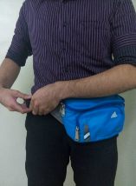

* 1. **LifeTag Web Application**
     1. **Installation and Creating an Account**

Access the LifeTag web application by visiting [www.lifetag.com](http://www.lifetag.com). Upon purchasing the wearable device, register and create an account using the serial number of the device. Fill out all the necessary fields for guardian, patient’s information and device configuration to complete the registration.

* + 1. **System Menu**

LifeTag web application consists of sections which let users create and manage an account. When logged in, users can view the current patient’s location through Google Maps.

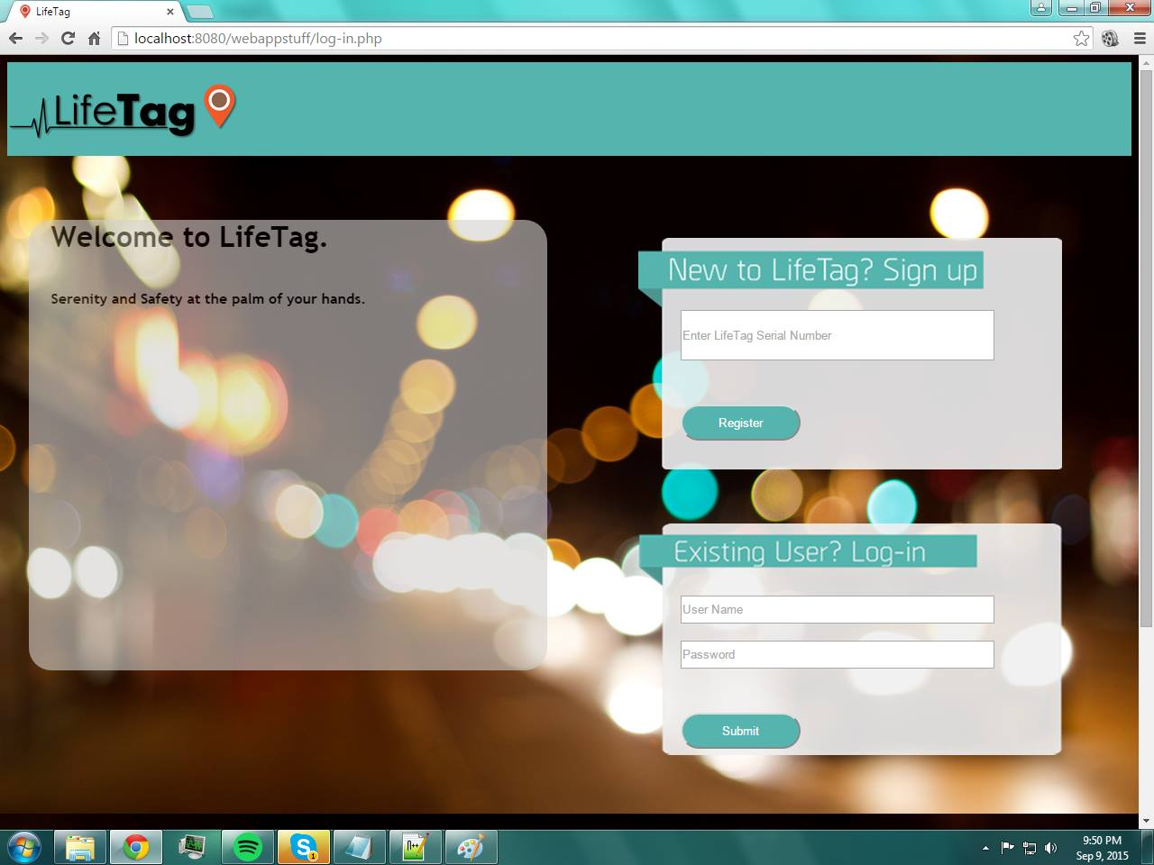

* Create account

Before a user can create an account, a valid serial number found in the wearable device is a requirement. After it is verified by the system, user can create an account. Guardian and patient fields should be completed accordingly.

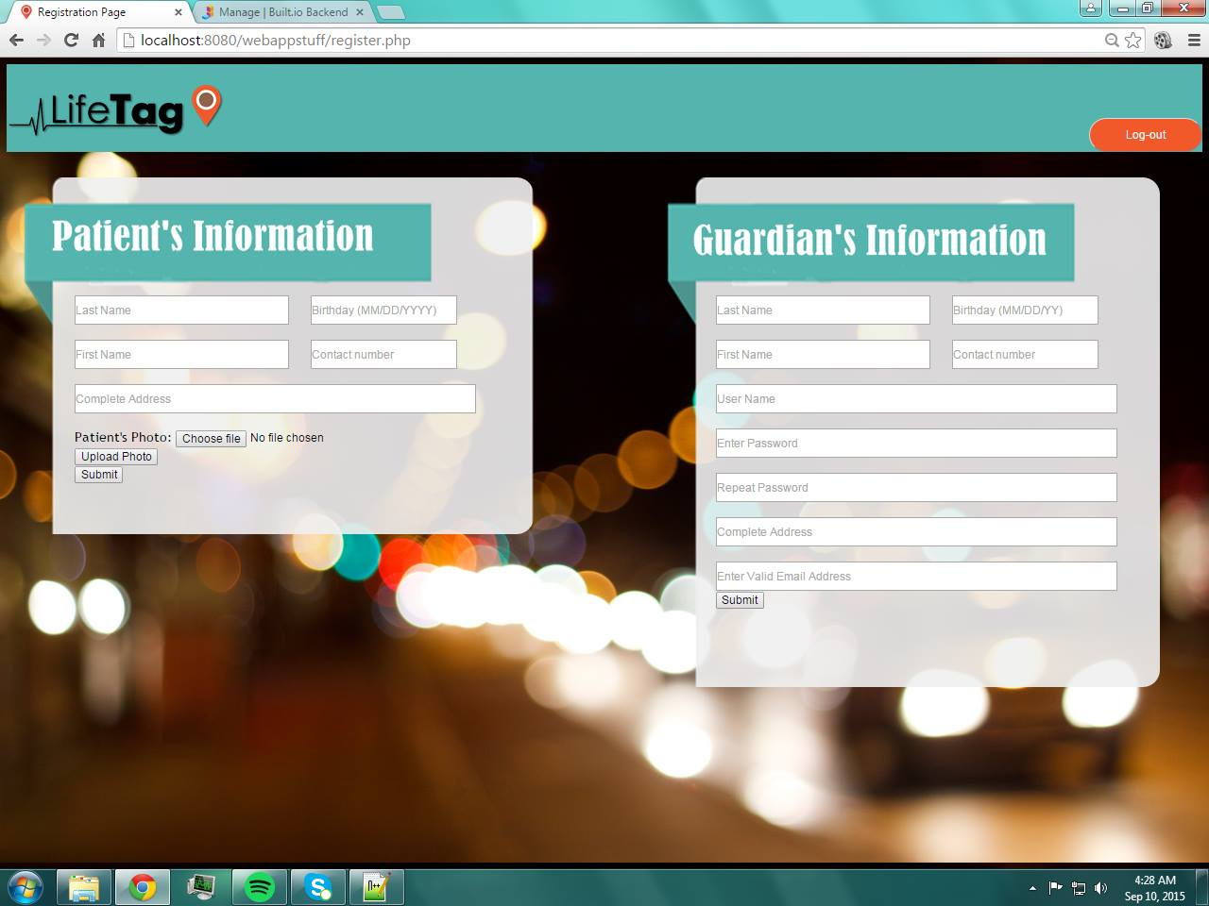

* Manage account

If there are possible changes in both guardian and patient information, user can modify it anytime.

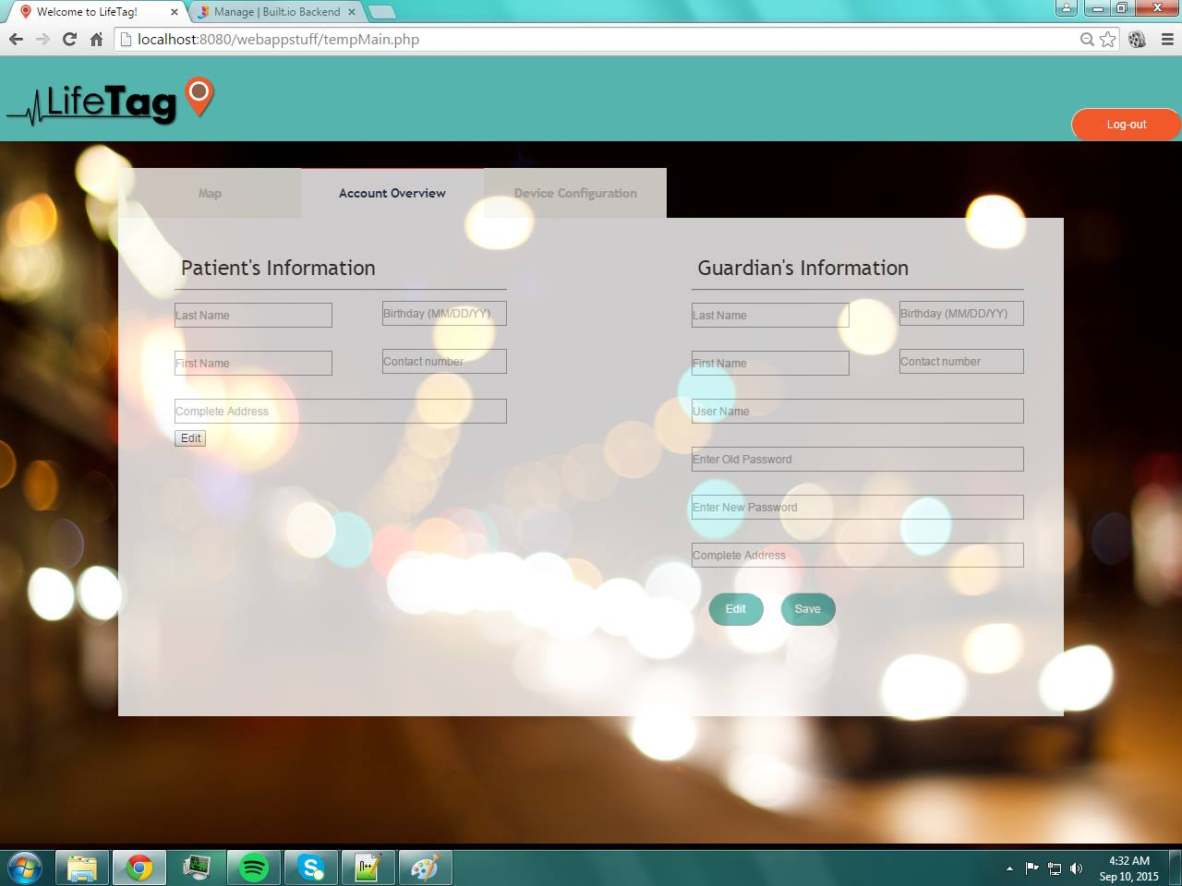

* Manage device configuration

Certain configurations in the Home and Pocket Wi-Fi networks are necessary. Home network pertains to the home’s internet connection and if the wearable device is not connected, it will trigger that the patient already left home; while Pocket Wi-Fi is worn along with the wearable device as it needs internet connection for sending out the alert notification.

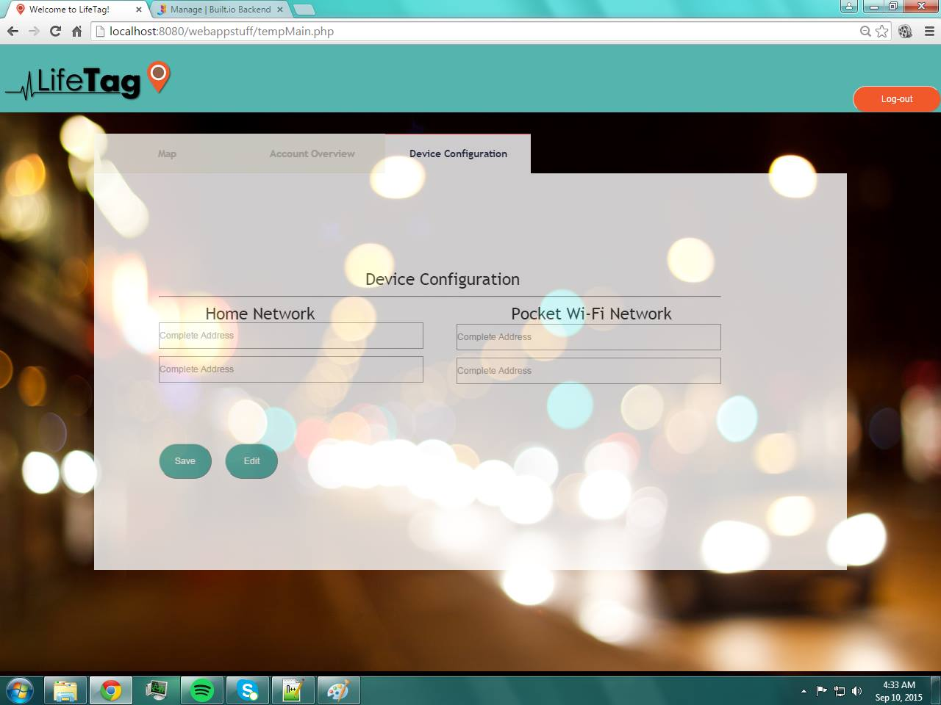

* View patient’s location through Google Maps

After creating and managing user’s account, viewing of patient’s current location is about to happen. Through Google Maps, real-time update and monitoring of patient’s location can be viewed in the web application.

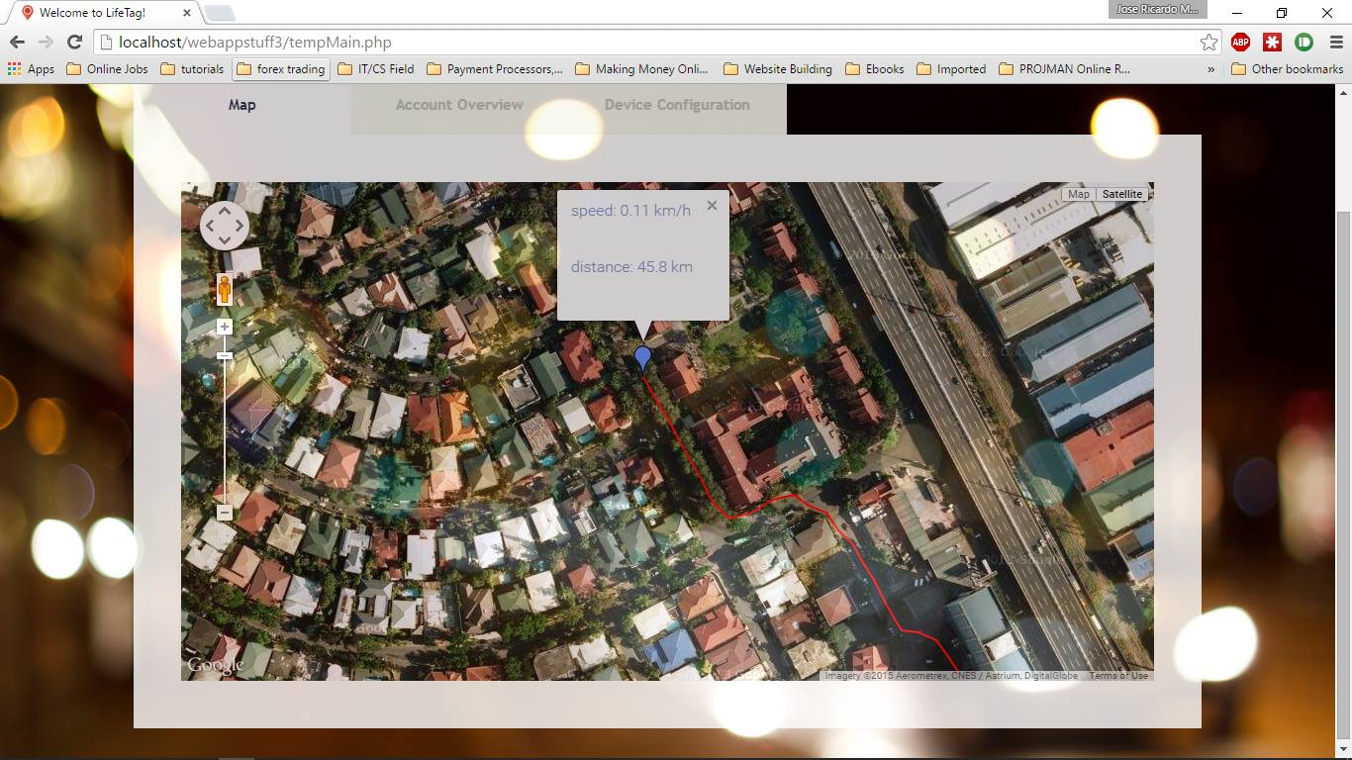

* 1. **LifeTag Mobile Application**
     1. **Installation and Logging In**

The newest installation version of the LifeTag Mobile Application is currently available and can be downloaded from Google Play Store and App Store. After creating an account, registered users can now log in into the mobile application using login credentials.

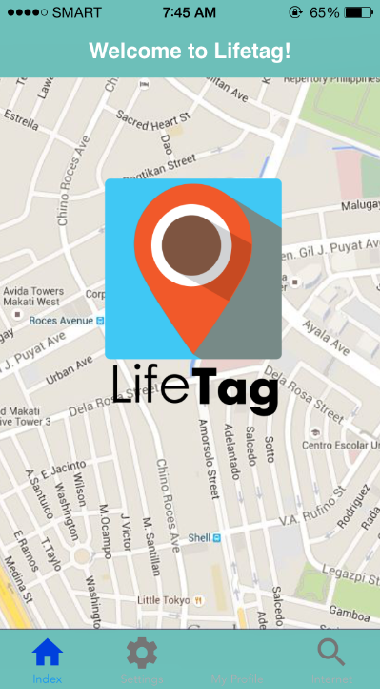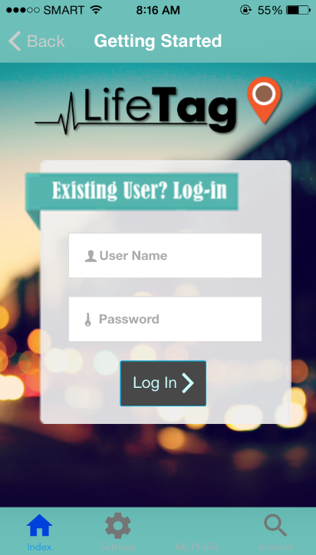

* + 1. **System Menu**

After logging in, it will now lead the user to the profile page of the patient. It shows patient’s name, date of birth, and address. As the alert notification has initiated, the user can view the patient’s current location through Google Maps by tapping the Get Location button.

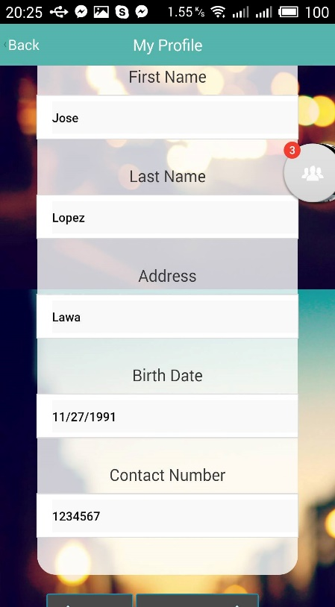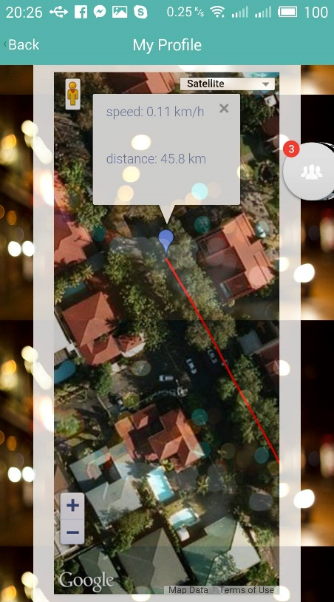

* + 1. **Exit Mobile Application**

LifeTag can be closed by tapping Logout button.